National University of Sciences & Technology

School of Electrical Engineering and Computer Science

Department of Computing

EE353: Computer Networks, BSCS-5AB Fall 2017

|  |  |  |
| --- | --- | --- |
| Home Assignment No 1  Covering the module Introduction | | |
| CLO 1: Understand the fundamental building blocks of Computer Networks i.e., Layered approach and protocols that make networking possible | | |
| Maximum Marks: 20 | | Instructor: Dr. Arsalan Ahmad |
| Date: 11th October 2017 | | Due Date: mid night 18th October 2017 |
|  | **Your Name: Mujtaba Shahid Faizi** | **Your Regn No: 131818** |  |

**General:**

This is an individual assignment. Fill in your details as listed above. Each student will attempt all these questions in this document and upload the completed document to the course LMS site by the deadline. Submission of pdf is not allowed. Show your calculations in any numeric question (Simply stating the answer would not suffice). Please avoid plagiarism; any such case would result in award of zero marks both to the “sharer” and the “acquirer” for the whole assignment component. Maximum score is 20 points that would be scaled back to 10 marks.

**Q1.** Suppose each user requires 500 kbps and is active only for 25% of the time. How many users can we multiplex on a 8 Mbps link if we want to fulfill user requirements with probability at-least 0.9 using packet switching? What is the Statistical Multiplexing Gain in this case? (4 points)

No. of users in circuit switching = $\frac{8 X{ 10}^{6}}{500 X {10}^{3}}$ = 16

p=0.25, q=1-p = 1-0.25= 0.75

0.901= $\left({50 \atop 0}\right){(0.25}^{0})\left({ 0.75}^{50-0}\right)$ + $\left({50 \atop 1}\right){(0.25}^{1})\left({ 0.75}^{50-1}\right)$ + $\left({50 \atop 2}\right){(0.25}^{2})\left({ 0.75}^{50-2}\right)$ +……

+ $\left({50 \atop 16}\right){(0.25}^{16})\left({ 0.75}^{50-16}\right)$ + $\left({50 \atop 17}\right){(0.25}^{17})\left({ 0.75}^{50-17}\right)$

P(X<17) =0.9

Where n =50, which represents the no. of users in packet switching.

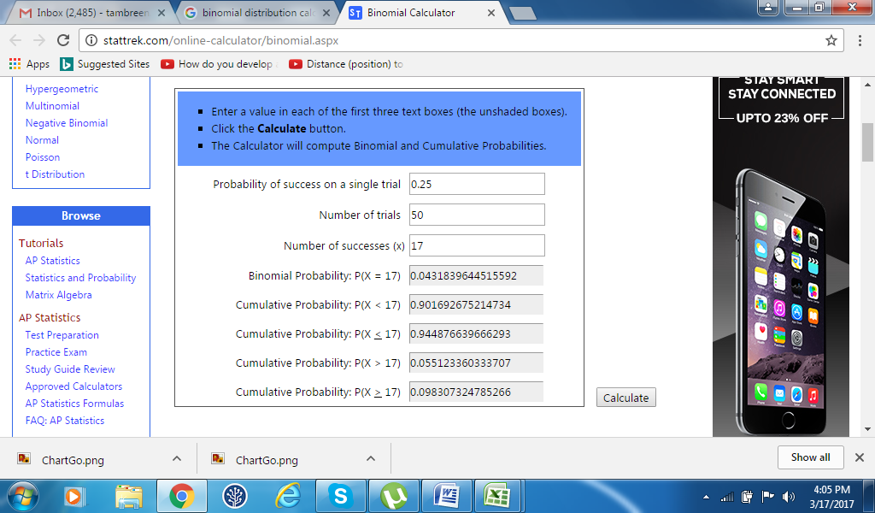



**Q2.** Consider two hosts, A and B, connected by a single link of rate *R* bps. Suppose that the two hosts are separated by *m* meters, and the propagation speed along the link is *S*meters/sec. Host A is to send a packet of size *L* bits to Host B. (4 points)

(a) Ignoring the processing and queuing delays, obtain an expression for the end-to-end delay.

Propagation Delay = $d_{prop}$ = $\frac{m}{S}$ sec

Transmission Delay = $d_{trans}$ = $\frac{L}{R}$ sec

End-to-end Delay = $d_{end-to-end}$ = $d_{prop}$ + $d_{trans}$ = ( $\frac{m}{S}$ + $\frac{L}{R}$) sec

(b) Suppose Host A begins to transmit the packet at time *t=0*. At time *t=dtrans*,where is the last bit of the packet?

It just left the host A.

(c) Suppose *dprop* is greater than *dtrans*. At time *t= dtrans*, where is the first bit of the packet?

The first bit is on the link.

(d) Suppose *dprop* is less than d*trans*. At time *t= dtrans*, where is the first bit of the packet?

The first bit has reached the Host B.

**Q3.** Provide feedback about this CN course/your instructor by suggesting any improvement that is required to enhance the quality and learning experience of this course. (2 points)

Some other tools should be introduced in the lab like MATLAB to learn how to deal with data. Perhaps use C++ to create sockets the next time. Difficult terms in the slides should be explained beforehand.

**Q4.** Consider the following scenario. Two groups Alpha and Bravo have measured RTT from their respective access networks through repeated request/reply to the same server.

Access Network for Bravo

Server

Access Network for Alpha

**Internet**

Bravo

Alpha

The Bravo group provided the following information about their experiment.

“We run a series of periodic request/reply measurements towards the server. For every request packet k, we record the departure timestamp tk and start a timer. Every request carries a unique ID in the payload that is replicated in the reply packet, in order to correctly correlate the request and the corresponding reply. When the reply packet is received, we record the value of the timer rk. If the reply is not received within a maximum predefined timeout, we mark the request as “lost” and write “-1” in the output file. Consecutive measurements are spaced by 20 ms. The experiment started at 9:16 AM of 11.10.2017”.Alphagroup followed the same methodology except that their start time of the experiment was 9:21 AM of the same day 11.10.2017.

You have been provided with two log files dataAlpha.txt and dataBravo.txt. These files contain two columns, start time tk and the measured RTT. Your task is to process the data, and determine that out of Alpha and Bravo access networks which network has better performance. You have to substantiate your answer with quantitative performance metric values that you have chosen. Also provide any graphs that you made to support your analysis. (10 points)

No. of packet losses in Alpha Network = 3466

No. of packet losses in Bravo Network = 949

Average RTT for Alpha Network (ignoring packet loss values) = 0.0278 sec

Average RTT for Bravo Network (ignoring packet loss values) = 0.0252 sec

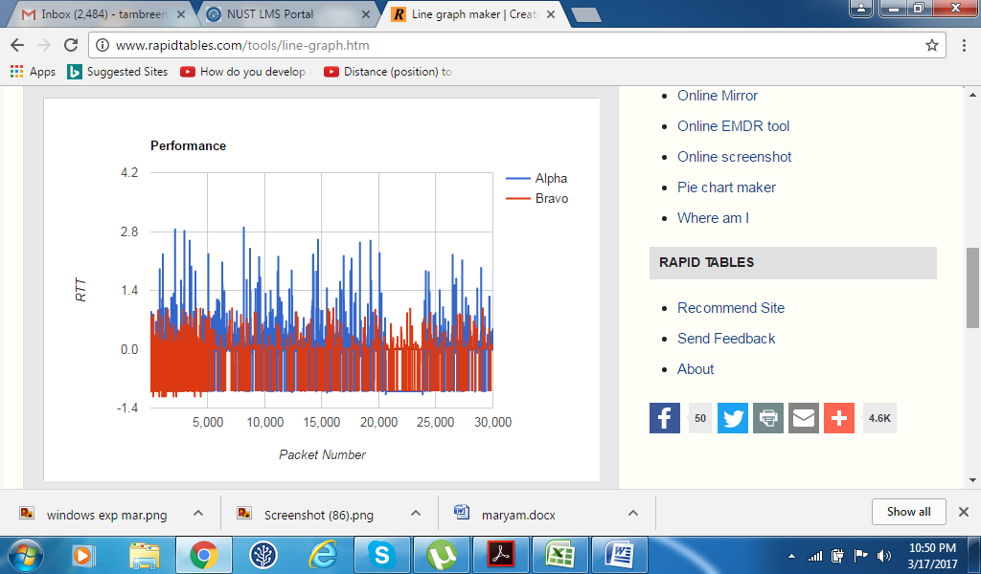

Bravo network is better than alpha since its RTT and packet losses are less as compared to alpha network.